# Create a Todo App in SAP Build Apps Community Edition Part 4 – Edit and Delete a Todo

This case assumes you finished Part 2 of Create a Todo App in SAP Build Apps Community Edition.

In this case, you will add a page with a form that allows the user to edit and delete Todos.

The first thing we’ll do is to enable to Get todo, Update todo and Delete todo services. Click on DATA in the top menu.

Select the Todo Data resource, select GET RECORD (GET) on the list on the left.

Click the toggle on the top right to enable to service.

Make sure /{id} is entered in the field to the right of the URL for the Relative path. It may just be a placeholder (grayed out). If it is, enter it.

Click the plus sign along the right side of the screen for the URL Placeholder.



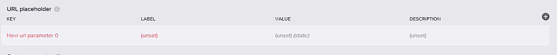

With the placeholder selected, configure the properties as shown below. The Key has to match the text between the curly brackets in the Relative path.

Repeat the process for the UPDATE RECORD (PUT) and DELETE RECORD (DELETE) services.

Return to the UI CANVAS and create a new page called Edit Todo and create a form like you did for the New Todo page.

We will need two buttons so drag a Row control below the form. The Row control allows you to divide the interface into columns. There are two columns by default.

Drag two buttons into the two columns and configure them as shown below. Use the Style tab in the Properties to change the style of the Delete button.

We need to pass the id of the tapped todo from the list page to the edit page. We use a Page parameter to do that. Click Variables.



Click Page Parameters

Then click ADD PARAMETER.

Select the parameter.

Configure the properties as shown.

Now we need to create a Data variable to contain the data retrieved from the backend system. Click DATA VARIABLES.

Click ADD DATA VARIABLE and select Todo.

Configure the data variable as shown.

Click the X icon below the ID to bind the Page parameter to the parameter the GetTodo function requires.

Select Data and variables.

Then Page parameters.

Select the Page parameter.

Open the logic pane by clicking the black bar at the bottom of the screen.

When the page loads, the Get record component will retrieve the Todo and set the data into the Data variable.

The Delay logic component will cause the Todo to be refreshed every 5 seconds. That will cause a problem unless the user is really fast. You can either increase the Time to wait or you can delete the Delay.

Return to the View and bind the Input fields as you did in the Create case.

Select the Save button and open the logic pane.

This logic is similar to the create logic. The difference is that you use an Update record component instead of Create record component.

Bind the ID (click the ABC icon) to the id of the Data variable.

Bind the Todo (click the icon with the two curly brackets beside Custom object) to the Data variable.

Finish the configuration of the logic in the same way you did for the Create todo.

Configure the logic for the Delete button as well.

Next, we have to configure the list on the My Todos page so when the user taps and item, it navigates to the Edit Todo page.

Open the My Todos page, select the list and open the logic pane.

Drag an Open page component onto the pane.

Configure it to open the Edit Todo page.

Click the X icon below the TodoID parameter.

We need to bind this to the id of the todo that was tapped. Select Formula.

Click Create formula.

Select Selected component properties.

Select self.tappedItem.id then click Enter +.

Now Launch the app. If you tap on a todo in the List:

The Edit Todo page opens with the Todo’s data:

Edit the data and save.

Et voila!

Test the delete as well.